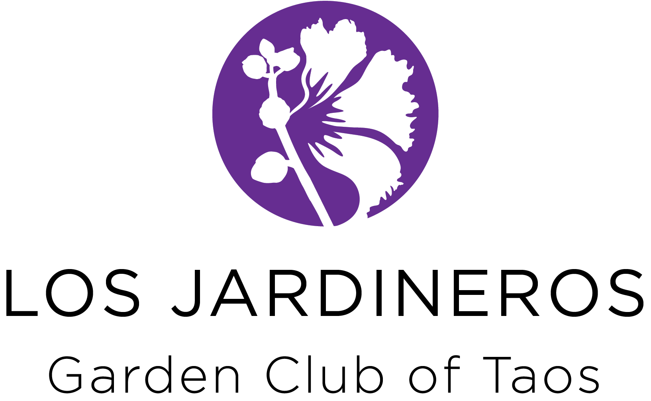

Grant Application and Project Requirements

Background
Los Jardineros Garden Club of Taos uses profits from its annual Garden & Home Tour to fund civic beautification or educational projects each year. The profits from the 2016 tour will fund the projects that actually are undertaken in 2017. The grants are awarded in October 2016 and extend through September 30, 2017.

Projects funded by these grants must provide environmental and/or horticultural education or beautification of public landscapes within Taos and the immediate surrounding communities. Projects that develop public landscapes must include a plan for the long-term maintenance of the landscape.

Project Requirements

Project Duration
Projects may begin after awards are announced and the Grant Agreements are fully signed and returned to Los Jardineros. Projects must be completed by September 30. Extenuating circumstances, beyond the control of the grantee, may result in an allowed carryover of project activities and funding to the next year. This must be requested in writing and be approved by Los Jardineros with an amended contract. In no case will funds be carried over for more than one year.

These are intended to be single year grants. However, if your project would be best implemented over multiple years and would have significant community impact, you can apply each year of your project. If a multiple year project is intended, please include subsequent years in your implementation plan and estimate the amount of funds needed for each year of the plan. Providing funding for the first year of a project in no way commits Los Jardineros to funding the project for subsequent years.

Project Activities
Project activities must be clearly outlined in the Grant Application. Each proposal must include a complete project activity timeline shown as Attachment B. Any requested change in the scope or activities of the project must first be brought to the attention of the Grants Chair or Liaison, who will then bring the matter to the attention of the Los Jardineros Board if the change is substantive. The Grants Chair will either grant approval or denial of the proposed change in writing. Failure to get approval for changes in advance of expenditures may result in a denial of reimbursement.

Project Expenditures
Expenditures must follow the project description in the grant application. Reimbursements will not be made for questionable expenditures. For example, if a project application is for plant materials for a garden, then Los Jardineros will not pay for hardscape materials. Los Jardineros will pay for labor only if it is included in the project application. In no case will Los Jardineros pay for project oversight/ supervision by an existing employee of the organization receiving grant funds. Grant funds are intended to supplement, not replace, an organization’s funding capacity.

Projects are typically done on a reimbursement basis, that is when a significant part or all of the project is completed. In exceptional cases, payment maybe made in advance but there must be justification for this. An example would be if other supporting funding sources have been depleted because of unforeseen expenditures to the organization. A request for advance funding must be made in writing to the Grants Chair. Remember, the Grants Committee is here to help you successfully complete your project, so keep your Liaison informed.

If the receipt does not clearly state what was purchased, a written explanation must accompany the receipt. For example, a credit card statement is not acceptable as it only states the total amount of a purchase and the business. The original receipt that shows what was purchased must be submitted with the reimbursement request.

The Grants Chair will approve/deny the request for reimbursement and forward it to the Treasurer for payment. Reimbursements must be requested prior to the end of the grant period.

Public Awareness of Project
Los Jardineros would like the public to be aware of the financial assistance we have provided. We may erect a small permanent sign at the project that notes funding was provided by Los Jardineros. Additionally, any public opening or dedication of the project should include recognition of Los Jardineros.

Project Reports
A written interim progress report is due on or before June 30 and a final written report is due on or before September 30. The interim June 30 report can be an email from the project contact person to the project liaison detailing progress to date, a comparison of work completed to the progress timeline and before and after pictures. If issues or problems have hampered the ability to attain project goals, please describe the problem and the selected solution to get the project back on track.

At a minimum, the final report should include the following topics:
- Project overview
- Maintenance plan
- Expenditure status report
- Photos of project

If there were problems, lack of funds, or other issues that would help the grantee or Los Jardineros in funding future projects, please include that information as well.

Technical Assistance
Los Jardineros can provide technical assistance with many landscaping issues, plant selection choices, or questions on report preparation. Coordinate requests for assistance with the Los Jardineros Project Liaison.

Project Selection Criteria

The Grants Committee and the Board of Directors will use the following criteria to select projects for grant funding:

Page 3

- Eligible organizations: Is this grant applicant an educational or not-for-profit organization in the Taos community or close surrounding area?

- Project objectives: Is the applicant’s proposed project consistent with the Los Jardineros Garden Club basic goals of environmental and horticultural education and/or beautification of public landscapes?

- Projects with good design and management: Is the applicant’s proposed project well- designed for the site, preferably using professional consultation? Is there a project manager who will coordinate the project, be responsible for executing the plan and allocating the grant funds appropriately?

- Long-term maintenance plan: Does the applicant provide a clear maintenance plan for long-term care of the landscape following completion of the project? Maintenance could include irrigation, pruning, seasonal weeding, fertilizing, etc.

- Detailed project budget: Does the application include a reasonable and well-researched budget detailing estimated costs for each phase of the project. Are the requested funds within the scope of our Los Jardineros grants?

- Project timelines: Can the proposed project be completed and grant funds expended within the grant year?

- Community recognition: Will the proposed project be of value to the community?

Written Proposal Components and Requirements

Proposals must include the following components:

Cover Page with Executive Signature
Each proposal must include the Cover Page stating the chief Executive’s support of the proposed project and the project requirements. This page must be signed by the organization’s Chief Executive. The Cover Page form is shown as Attachment A.

Narrative
The narrative must discuss each of the following questions in the order shown below.

- Project Objectives: What will be accomplished? How will the project meet the objectives of the Garden Club? When plantings are included in your project, you must describe the irrigation infrastructure to be used to ensure the long-term viability of the plants.
- Who will manage the project? How does this person answer to the organization’s chief executive?
- Who will oversee the maintenance of the landscape (if applicable) after the project is completed? What is the source of funds for maintenance?
- How will the project manager ensure that the project is completed on budget and on time?
- Describe how the organization will publicize or encourage public use of the landscape or project.

Project Activities and Timeline
Complete the Activities Timeline Form shown as Attachment B. You may add as many pages as necessary to completely show the activities necessary for your project.

Project Budget and Detail
Complete the Budget and Expense Detail Form shown as Attachment C. Detailed budgets are preferred. If contractors will be used for the project, attach copies of their bids. If you are including plants, you must also install an irrigation infrastructure.

Project Diagrams/Plans/Sources
Provide pictures of the project area as it now looks and landscape drawings for the project.
If this is an educational project, include sources and proposed written materials.

GRANT APPLICATIONS MUST BE RECEIVED BY SEPTEMBER 1, 2016.
MAIL COMPLETED APPLICATIONS TO:
LOS JARDINEROS GARDEN CLUB OF TAOS, CIVIC GRANT APPLICATIONS
PO BOX 3103, RANCHOS DE TAOS, NM 87557

Grant Application Checklist

Does your proposal include the following?

Application Cover Page with Executive signature

Narrative with topics covered in the order shown on page 4

Project Activity Timeline

Budget and Expenditure Detail

Pictures, Drawings, Landscape Plans, Educational Materials

Will the completed application reach the Los Jardineros address by September 1st?

Attachment A

Los Jardineros Garden Club of Taos

Grant Application Cover Page
Applicant Organization
Street Address
Community
Contact Person
Telephone Number
Email Address
Funds Requested |  | $
Project Description (50 Words or Less)
As the Chief Executive of the Applicant, I acknowledge the submission of this application and fully support the completion of the project described by our staff and volunteers. Further I have read the grant requirements and agree to follow them, if the application is fully or partially funded.
Signature |  |  | Printed Name | Date

Attachment B

Activity Timeline
Primary or Secondary Activity | Start Month | End Month | Name of Responsible Person

Attachment C
Budget and Expenditure Detail
Item Description
Supplies and Equipment | Quantity | Price | In-kind or Donated | Total
Supplies and Equipment Subtotal
Personnel (Title and Function) | # Hours | Wage | In-Kind | Total
Fringe Benefits
Personnel Subtotal
Contractors (Name and Function)
Contractor Subtotal
Total Requested Funds
Attach any bids from contractors or explanations of in-kind, donated services or materials, or other project related grants.

