Agriculture Implementation Research & Education (AIRE )
!"# %&' ()'*+ , -.&/0 12 , #3435 64347 34583993 , 64347 33"8#:"3
;;;<=>&;?.>@)>/<&>=
/&'?)'*+?.>@A=@.*'<B&@
DATE: September 30, 2017
TO: Los Jardineros Garden Club of Taos RE: 2017 Project Report
FROM: Miguel A. Santistevan
Director & President, AIRE

Project Overview
In January 2017 the non-profit organization AIRE was awarded an $1800 grant from the Los Jardineros Garden Club of Taos to implement a "three sisters" garden in the arroyo next to the Taos Charter School (TCS) in addition to hosting a tree-pruning workshop to maintain fruit trees located on the school grounds. Once notice of the grant award was made, plans were made to purchase some equipment needed and relationships were refined with local arborists Ben Wright and Paul Bryan Jones, Jeremy Jones of the Taos Charter School, and Beth Enson of the Heartwood Coalition to partner on the workshops. Though an early request was made to modify the budget for some additional funds, the project did not exceed the original grant request amount by more than $50.
An initial purchase was made of two orchard ladders from the Country Farm Supply Store in Espanola in addition to a weed flamer and accessories that were ordered online from Peaceful Valley Farm Supply. The orchard ladders were needed for perpetual use in tree care at TCS in addition to other sites and the weed flamer was purchased to help manage weed populations within the arroyo environment for the establishment of the garden. See attached receipts.
On March 20, 2017 the initial tree pruning workshop was held with Ben Wright and Paul Bryan Jones taking the lead. See Flyer #1. Press releases to the local newspaper and radio were created and notice of the workshop was sent out on listserves for the Taos Tree Board as well as notification over Facebook. Approximately 20 participants were in attendance (see attached
sign-in sheet) and we were able to care for the pear, apple, plum, and some of the apricot trees on the site. Some of the apricot trees had already flowered and so we were not able to prune those trees. With much enthusiasm from the principal of TCS and the participants in the workshop, we were able to provide much needed care for the trees that were well established for several years but had never been pruned. See photo plate 1. A blog posting was made to showcase this event. (https://solfelizfarm.wordpress.com/2017/03/20/tree-pruning-workshop-a-success/)
Online purchases were made for irrigation and burn-control supplies from Farm Tek and three broadforks from Johnny's Selected Seed to prepare the soil for planting. Compost was purchased from Earthgoods to help amend the soil. See attached receipts.
A workshop to break ground for the three-sisters garden was organized for late April but was actually snowed out! We were able to reschedule the workshop for May 6, 2017 and had about 12 people in attendance (see attached sign-in sheet and Flyer #2). We were able to network with Edward Gonzales of the National Immigrant Farming Initiative to share his experience with dryland farming in the traditional agriculture methods of northern New Mexico. Edward was also able to help us with the clearing of the land using the weed flamer as well as using the broadforks to aerate the soil and incorporate the compost. A fire permit was acquired and the garden hose with sprayer attachment was used to ensure safety in the burning of the weeds on site. Many mounds with compost and wells to hold rainwater were prepared for future planting by the student at TCS. We were able to support a 6th grade student, Mariel Gomez, in planting native flowering plants for pollinators on this day as well. See photo plate 2 and blog

post for a narrative of this event. (https://solfelizfarm.wordpress.com/2017/05/06/dryland-three- sisters-garden-created-at-school/)
On May 15, 2017 Miguel Santistevan and his wife Margaret Garcia got together with the Kindergarten, First Grade, and some Second Grade students to plant the arroyo garden. The students were given a presentation about the three-sisters gardening method and each student was given three seeds of corn, beans, or squash to plant in a particular mound. The garden was planted on the traditional planting day for northern New Mexico, Dia de San Isidro. We were able to contribute cota, a native plant used for tea that is also excellent for native pollinators, for planting in the border of the three sisters garden. See photo plate 3 for pictures of the day's activities.
The motivation for the dryland three-sisters garden was to experiment and demonstrate that this style of agriculture is possible in our high desert environment. Native Americans of the region practiced this style of agriculture in generations past, and it was hoped the garden would result in success through the production of acclimated seed for continuation into future seasons. The seeds used in the garden came from Miguel Santistevan's collection from a seed stock that had already been productive in dryland environments. The white corn planted had survived on one irrigation in a past agriculture season in Taos, the beans were white tepary beans from Southern Arizona and were grown in a total dryland environment in Taos in the past, and the squash was a variety from Hopi, characterized by dryland agriculture methods, and acclimatized to the Taos environment in a past growing season. The hope was that the arroyo would receive sufficient moisture from the uplands that feed it during rainstorms and that the acclimatized seeds would be able to make best use of the residual moisture while exhibiting resilience between rains.
The garden was monitored periodically throughout the growing season. Twelve students and two facilitators of the 'Youth Global Leadership' program from Boulder, Colorado were able the visit the garden on June 9 and were inspired to learn about traditional agriculture methods unknown to them prior.
The bean plants were small but flowered and began a process of producing seed. The corn was slow growing but persisted and seemed as if it would produce. The squash clearly suffered a lack of moisture at the beginning of the season and did not produce fruit until rains started to come at the end of July/beginning of August. It appeared as if the arroyo environment suffered a frost in late August/early September much earlier than seen in the rest of Taos. The squash that was beginning to form was then aborted but it seemed as if the corn and beans were still on track to produce. The first harvest of corn unfortunately showed either a lack of pollination or some other factor that resulted in cobs with no seed. Over a dozen legumes of white tepary beans were harvested and resulted in a small handful of mature seed. These beans show the greatest promise for success in this kind of agriculture strategy. See photo plate 4 for pictures of the garden and harvest.
On August 1 a dryland garden care/summer pruning workshop was held as a follow-up to our Spring workshops (See Flyer #3). About 8 participants were able to learn and help care for the arroyo garden in a workshop that showcased the practices of soil cultivation, mounding soil around the plants, and other themes in dryland and late-season gardening (see attached sign-in sheet). Then Ben Wright and Paul Bryan Jones shared their skills in summer pruning on the apricot trees that could not be pruned in the Spring. See photo plate 5 for images from that day.
The project was a success in the care of the trees and the development of relationships that will result in future tree-care and community education opportunities. Another success was the realization of what adaptations should occur to enjoy increased yields for the arroyo garden project in the future. The greatest success was in the process of building relationships between AIRE, the Taos Tree Board, the Heartwood Coalition, and the administrators and teachers of TCS to implement the project. All parties are enthusiastically looking forward to more pruning

workshops and another arroyo garden in 2018. The investment made in AIRE by the Los Jardineros Garden Club for the purchase of needed equipment will carry over into future years of programmatic activity. Specifically, we are planning on continuing the pruning and gardening workshops on the TCS site for the benefit of the TCS program, the extended community, and the development of resilient agriculture methods into the future.

Maintenance Plan
Maintenance of the arroyo garden was minimal by design in the curiosity in the potential for dryland agriculture on the site. These agriculture methods have been documented in many anthropological publications such as Maxwell and Anscheutz in "Gardens of Prehistory" edited by Killion. Increased garden care in the form of additional cultivation activities and workshops was desired but not possible given various time constraints. The plan for next season is employ a drip irrigation system for the squash and perhaps the corn while continuing to develop dryland methods using our white tepary bean seed stock. The hope will then be to partner with Margaret Garcia and her 'Taos Real Food' operation to be able to prepare the harvest for the students' enjoyment, facilitate cooking classes, and/or provide the produce to Micah Roseberry of the Farmhouse Cafe and contribute to her 'Farm- to-School programs.' There is interest by all parties involved in this project to continue the tree pruning workshops and to continue to develop the TCS site as a place for community agricultural education.

Expenditure Report

The following table lists the total expenditures and reimbursements made from this 2017 grant. See attached copies of the receipts in the 'RECEIPTS' section below.

Item | Description | Vendor | Amount
1. | Orchard ladders (10' and 14') | Country Farm Supply. Española, NM | $661.47
2. | Backpack weed flamer and valve. | Peaceful Valley Farm Supply. Grass Valley, CA | $326.97
3. | 3/22/17. 3 Hardpan Broadforks. | Johnny's Selected Seeds.  Winslow, ME | $647.00
4. | 3/22/17. Propane for backpack flamer | Romeros Rio Grande Propane, Taos NM | $ 7.04
5. | 5/5/17. 12 T-posts for garden  fencing. | Rio Grande Ace Hardware  Taos, NM | $66.29
6. | 5/5/17. 6 bags Compost | Earthgoods Taos, NM | $ 137.70
 |  | TOTAL | $1846.47

Thank you for your support of AIRE and our mission "To gather the people and plant the fields!" Please visit us at www.growfarmers.org for future updates on our activities and observations with regard to agricultural implementation, research, and education!

Photos

Photo Plate 1 - Tree Pruning workshop on March 20, 2017.
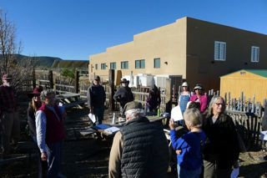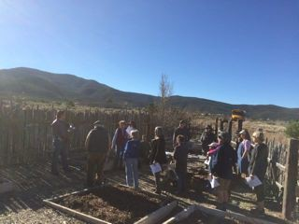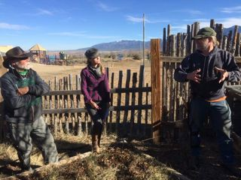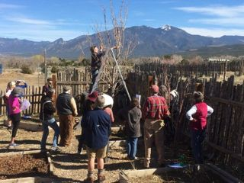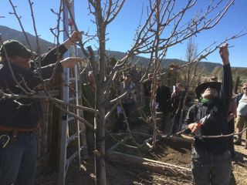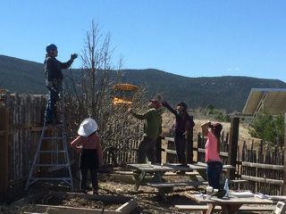

Photo Plate 2 - Dryland agriculture workshop on May 6, 2017.
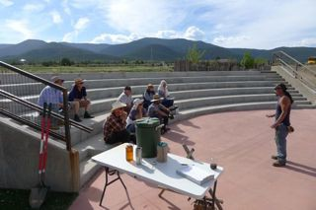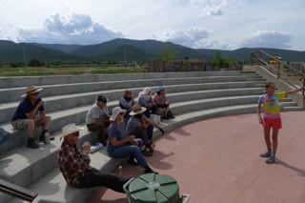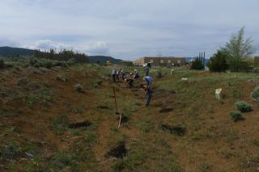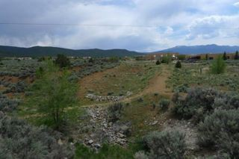

Photo Plate 3 - Planting with the students of TCS on May 15, 2017.
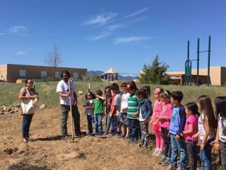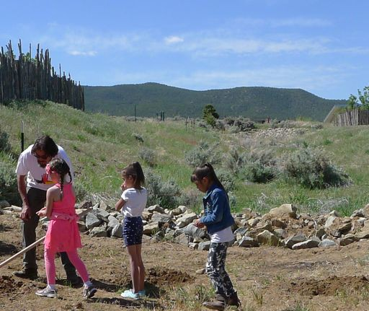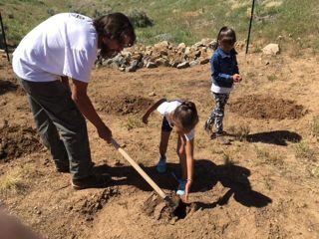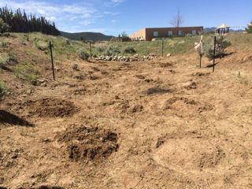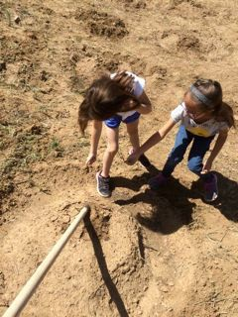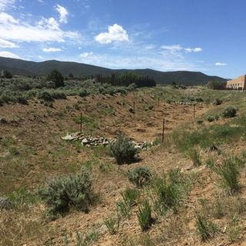

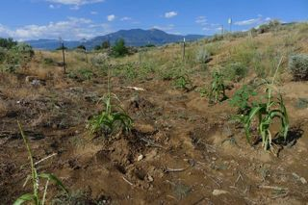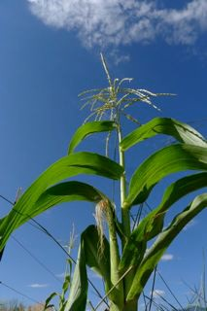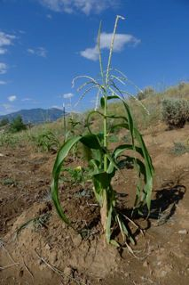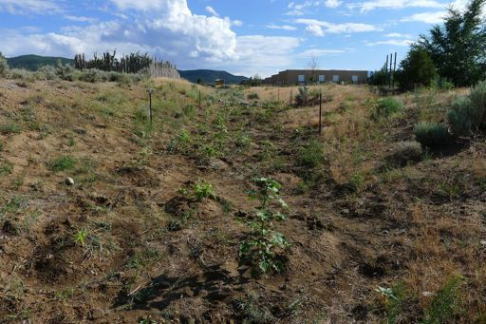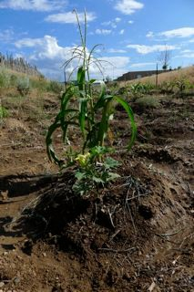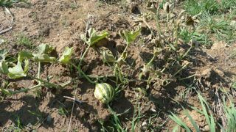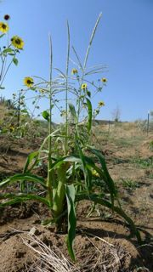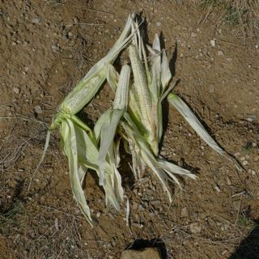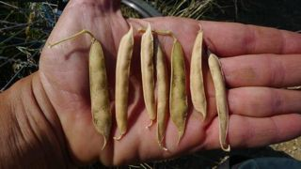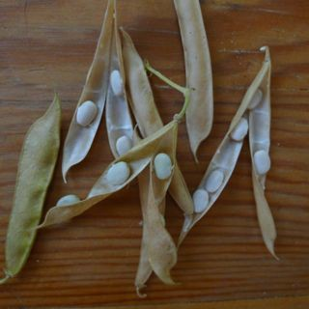Photo Plate 4 - Photos of garden-in-progress and white tepary bean harvest.

'''

Photo Plate 5 - Summer pruning workshop on August 1, 2017.
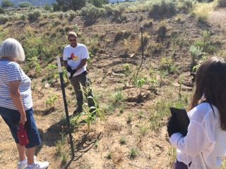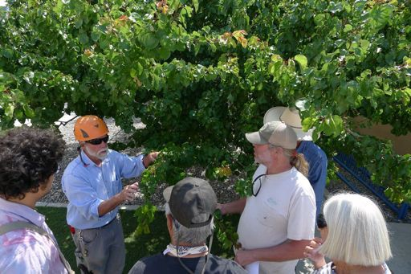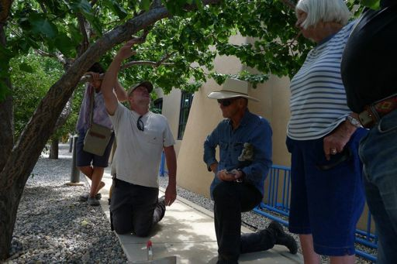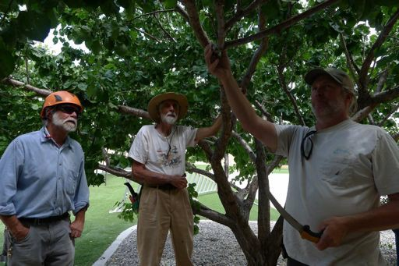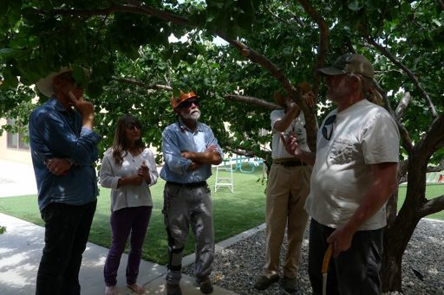

FLYERS FLYER #1

!"#"$"%"&' )*+ ,+-.)/001 20-34506' )*+ 7-08 7.++ 90-.1'
:08 ;-.146+.08 <-.1+6 23=>' ? )*+ 7-08 2*-.)+. @A*003 B.+8+6)8C
7$%% 2!$% -61 D$EF#F< GHGC
- *-618I06 /0.J8*0B
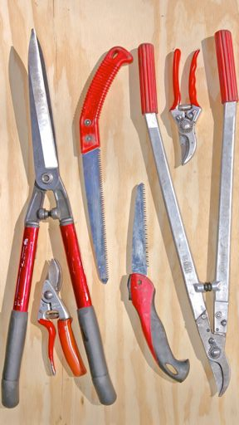
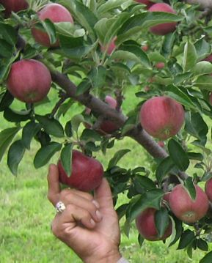
!"#$ &$'() *("# 9+6 K.4L*) ')+ D-=3 9.M-6 ;06+8
"* ,-$ .$'(,/""+ !"'&01") -"/ ," 2'($ *"( ')+ 3(4)$ *(40, ,($$5
*"( *""+ ')+ 6$'4,78 9$ /0&& 3(4)$ ,/" 5#'&& "(2-'(+5 ', ,-$

7-08 2*-.)+. @A*003:
;<=>= ?'5$" @$& !'A") B'5,: C'"5: DE FGHG<I

N061-M' N-.A* OH' PCHH !NIGOCHH DN
E$$, 0) ,-$ !'*$,$(0' "( 0) ,-$ J'5K$,6'&& !"4(, '($'
!"#$% '"($)"*+ ,-'')"*+ .$/ %,-0)* ;0* 7"4 -'L$ 5"#$MI

Q R$%% Q
!'&& E0N4$& O')15,$L') ', ;HGHI GG>PF=>G *"( #"($ 0)*" "( $#'0& ', 5"&*$&0Q*'(#RN#'0&M2"#
S TN(024&,4($ U#3&$#$),'1") V$5$'(2- W B+42'1"): ///MN("/*'(#$(5M"(N

FLYER #2

!"#"$"%"&' )*+ ,-./012.*+ 3-./21 4567'
8 9:2 ;-*+ 4:-.92. <=:**5 >.2+219+?
!.0/@5-1/ 3-./21 A.2>-.-B*1?
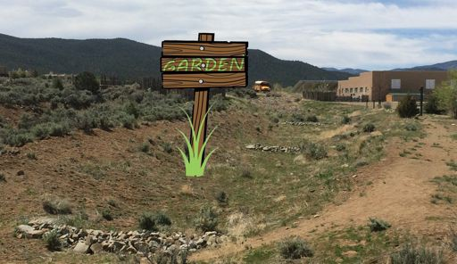
- :-1/+@*1 C*.D+:*>
!"#$ &$'() *("# E0F625 <-1B+92G-1 '+",- '(./0&')/1
2'(/$).)2 ')/ -3$ +'1.41 "* 5$(#'4,&-,($ '1 6$
7($7'($ ') '(("8" *"( ' 143""& 2'(/$) '- -3$ ;-*+ 4:-.92. <=:**59
:;<=< 5'1$" >$& !'?") @'1-9 A'"19 BC DEFE;G

H.0/-I' !>.05 JK' L?MM !E@NJ?MM AE
C$$- .) -3$ H'1I$-+'&& !",(- '($'
!"#$% '(") %*(+,-.

O H$%% O
!'&& C.2,$& J')K1-$L') '- :FEFG EE=0D<=E *"( #"($ .)*" "( $#'.& '- 1"&*$&.M*'(#N2#'.&O4"#
P Q2(.4,&-,($ R#7&$#$)-'K") S$1$'(43 T @/,4'K")9 666O2("6*'(#$(1O"(2

FLYER #3
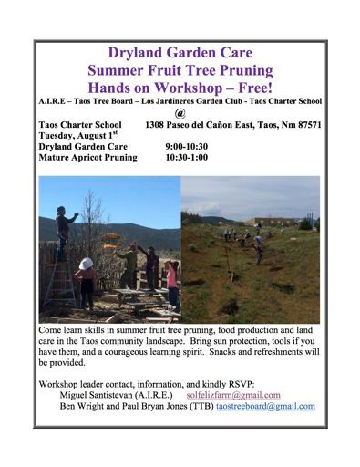

SIGN IN SHEETS

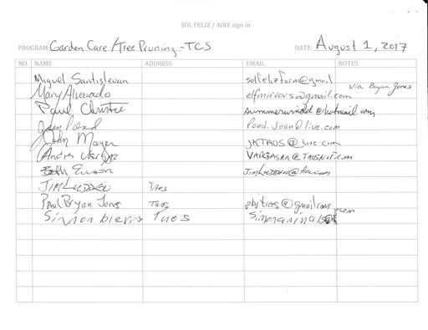

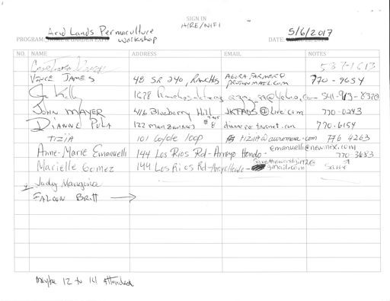

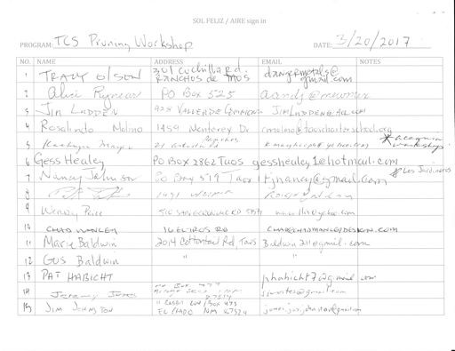

RECEIPTS

Pe c ful Voll y F.:um&G r
Suppty
Invoice
t
a•
1

Johnnys
,«J.
I JI:./, J;wf.. - --
,,, JI :V--oJr

:t

